**Project Design Phase-II**

**Technology Stack (Architecture & Stack)**

|  |  |
| --- | --- |
| Date | 15 October 2022 |
| Team ID | PNT2022TMID30076 |
| Project Name | Project – SMART FARMERS USING IOT |
| Maximum Marks | 4 Marks |

**Technical Architecture:**

The Deliverable shall include the architectural diagram as below and the information as per the table1 & table 2

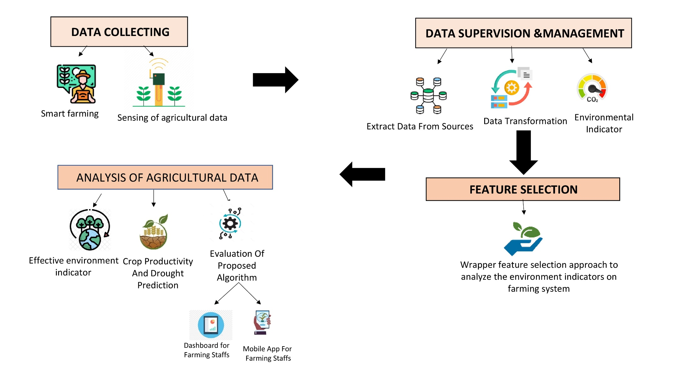

**Table-1: Components & Technologies:**

|  |  |  |  |
| --- | --- | --- | --- |
| **S. No** | **Component** | **Description** | **Technology** |
|  | User Interface | User Interact with the application through Mobile phones, laptops etc. | HTML, CSS, JavaScript etc. |
|  | Application Logic-1 | Logic for a process in the application | Python. |
|  | Application Logic-2 | Logic for a process in the application | Internet of Things, Artificial Intelligence, Big data Analytics. |
|  | Application Logic-3 | Logic for a process in the application | Crop Monitoring system, Drones. |
|  | Database | Data Type, Configurations etc. | DBMS, MySQL, NoSQL, etc. |
|  | Cloud Database | Database Service on Cloud | IBM Cloud, Cloud SQL. |
|  | File Storage | File storage requirements | Grain storage, Data storage. |
|  | External API-1 | Purpose of External API used in the application | Auto grow API, Green book API, Open food Network API. |
|  | External API-2 | Purpose of External API used in the application | Deep green Plant Diagnosis API. |
|  | Machine Learning Model | Purpose of Machine Learning Model | Linear Regression model, Neural network, K Nearest Neighbour etc. |
|  | Infrastructure (Server/Cloud) | Application Deployment on Local System/Cloud  Local Server Configuration  Cloud Server Configuration | Leverage the Cloud. |

**Table-2: Application Characteristics:**

| **S. No** | **Characteristics** | **Description** | **Technology** |
| --- | --- | --- | --- |
|  | Open-Source Frameworks | List the open-source frameworks used | NodeJS, MongoDB. |
|  | Security Implementations | List all the security / access controls implemented, use of firewalls etc. | Threat Prevention, Scalable performance. |
|  | Scalable Architecture | Justify the scalability of architecture (3 – tier, Micro-services) | The website traffic limit must be scalable. |
|  | Availability | Justify the availability of application (e.g., use of load balancers, distributed servers etc.) | In future any modification in the application it will not affect the user data. |
|  | Performance | Design consideration for the performance of the application (number of requests per sec, use of Cache, use of CDN’s) etc. | Front page load time must be no more than 5 seconds |